Antony Roshan

Angular

**app.component.html**

<h1 style="background-color: aqua ;text-align: center;">Angular Training </h1>

<h2 [style.background-color] = "colorFunction()" [style.text-align] = "alignFunction()">Welcome to {{title}} </h2>

<h2 style="background-color: greenyellow;text-align: center;">

<div [ngStyle]="{'color' : 'Blue'}">If Statement</div>

<div *ngIf="showMsg; else showElseMsg">Angular is running</div>

<ng-template #showElseMsg>Angular is not running (else part)</ng-template>

</h2>

<h2 [ngSwitch]="choice" style="background-color: blanchedalmond; text-align: center;">

  <div [ngStyle]="{color:colorDisp}">Switch Statement</div>

<div *ngSwitchCase="1">Today is Monday</div>

<div *ngSwitchCase="2">Today is Tuesday</div>

<div *ngSwitchCase="3">Today is Wednesday</div>

<div *ngSwitchCase="4">Today is Thursday</div>

<div *ngSwitchCase="1">Today is Friday</div>

<div *ngSwitchCase="1">Today is Saturday</div>

<div *ngSwitchCase="1">Today is Sunday</div>

</h2>

<table class="table" style="background-color: rgb(238, 217, 217);">

    <tr>

        <th>Brand Id</th>

        <th>Brand Name</th>

        <th>Index</th>

        <th>First</th>

        <th>Last</th>

        <th>Even</th>

        <th>Odd</th>

    </tr>

<tr *ngFor="let count of Brands;index as i;first as f;last as l;even as e;odd as o">

    <td>{{count.brandid}}</td>

        <td>{{count.brandname}}</td>

        <td>{{i}}</td>

        <td>{{f}}</td>

        <td>{{l}}</td>

        <td>{{e}}</td>

        <td>{{o}}</td>

</tr>

</table>

<button mat-button>Primary</button>

<button mat-button color="Primary">Primary</button>

<button mat-button color="accent">Accent</button>

<router-outlet></router-outlet>

**app.component.ts**

import { Component } from '@angular/core';

@Component({

  selector: 'app-root',

  templateUrl: './app.component.html',

  styleUrls: ['./app.component.css']

})

export class AppComponent {

  title = 'Angular Tour';

  colorFunction()

  {

    return "orange";

  }

  alignFunction(){

    return "center";

  }

  showMsg = false;

  choice = 2;

  Brands = [

    {brandid : 30,brandname : 'Realme'},

    {brandid : 10,brandname : 'One Plus'},

    {brandid : 50,brandname : 'Samsung'},

    {brandid : 20,brandname : 'Poco'},

    {brandid : 40,brandname : 'Nokia'}

  ]

  colorDisp = 'blue';

}

**app.module.ts**

import { NgModule } from '@angular/core';

import { BrowserModule } from '@angular/platform-browser';

import { AppRoutingModule } from './app-routing.module';

import { AppComponent } from './app.component';

import { BrowserAnimationsModule } from '@angular/platform-browser/animations';

import { MatButtonModule } from '@angular/material/button';

@NgModule({

  declarations: [

    AppComponent

  ],

  imports: [

    BrowserModule,

    AppRoutingModule,

    MatButtonModule,

    BrowserAnimationsModule

  ],

  providers: [],

  bootstrap: [AppComponent]

})

export class AppModule { }

**angular.json**

"styles": [

              "./node_modules/@angular/material/prebuilt-themes/indigo-pink.css",

              "src/styles.css",

              "./node_modules/bootstrap/dist/css/bootstrap.min.css"

            ],

            "scripts": [

              "./node_modules/bootstrap/dist/js/bootstrap.min.js",

              "./node_modules/popper/index.js",

              "./node_modules/jquery/dist/jquery.min.js"

**Bootstrap**

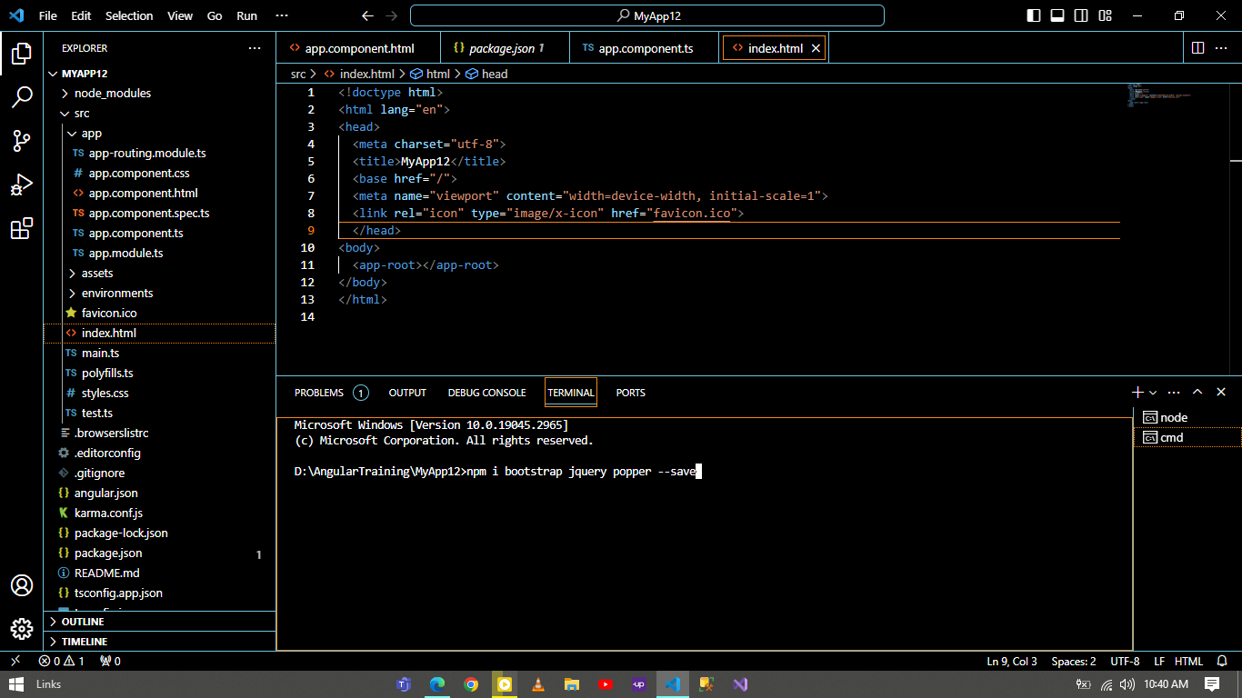

**Angular Material**

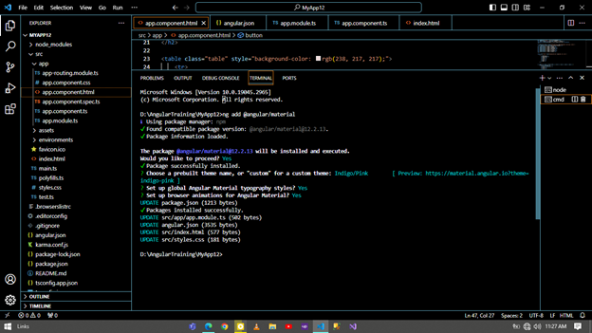

Browser Output

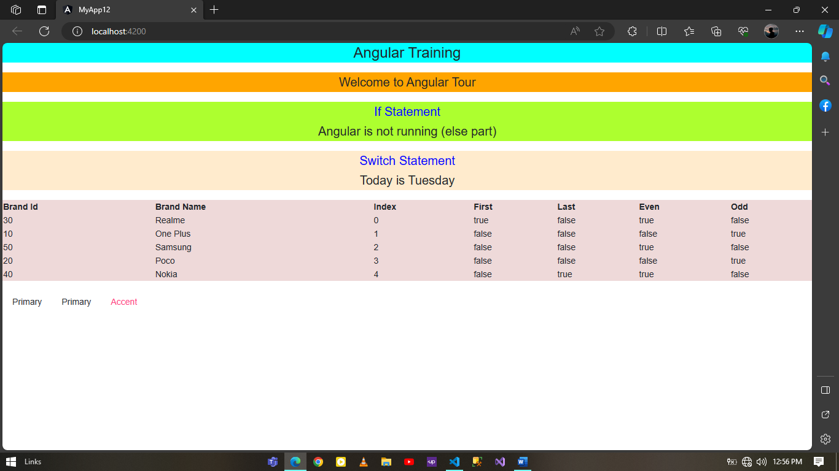

**Style Binding**

**app.component.html**

<h2 class="c1">{{title}}</h2>

<div [ngClass]="'c1'">This is Angular class example</div>

<div [ngClass]="'c1 c2'">This is Angular class example</div>

<div [ngClass]="styleClsProp">This is Angular class example 3</div>

**app.component.css**

.c1{

    background-color: red;

    color: #fff;

}

.c2{

    color: black;

    font-size: 30px;

}

.c3{

    color: violet;

    background-color: yellow;

    font-size: 20px;

}

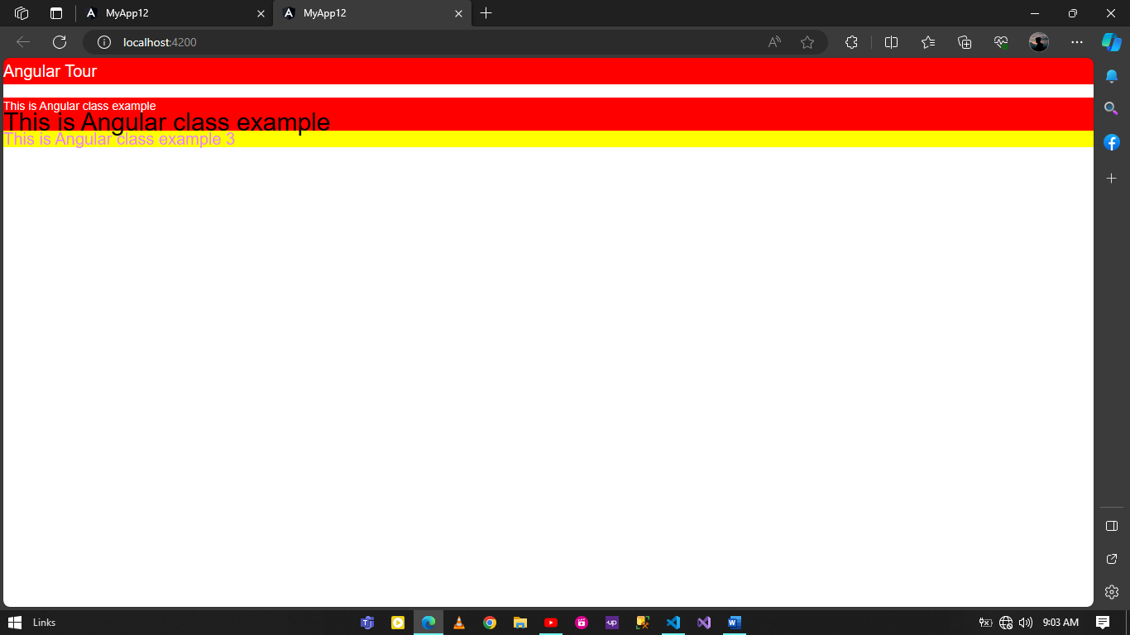

**Event Binding**

**app.component.html**

<button (click) = "sayHello();">Click to say hello</button>

<div (mouseover)="highlightBGColor();">Highlight me</div>

<input type="text" (focus)="inputBox();">

**app.component.ts**

import { Component } from '@angular/core';

@Component({

  selector: 'app-root',

  templateUrl: './app.component.html',

  styleUrls: ['./app.component.css']

})

export class AppComponent {

  title = 'Angular Tour';

  success = true;

  styleClsProp = 'c3';

  sayHello()

  {

    console.log("Hello world")

  }

  highlightBGColor(){

    console.log("It is highlighted")

  }

  inputBox(){

    console.log("It is input box")

  }

}

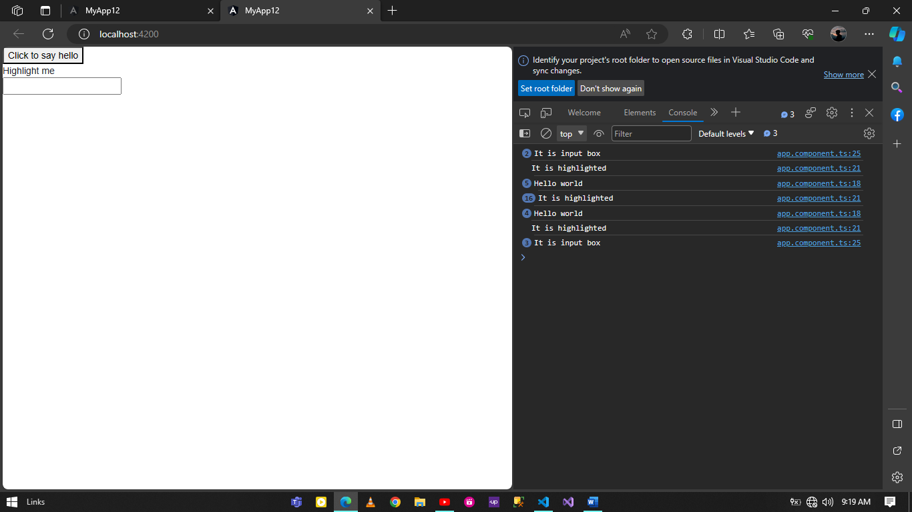

**Two Way Data Binding**

**app.component.html**

<input [(ngModel)]="username">

<div>{{ username }}</div>

**app.component.ts**

import { Component } from '@angular/core';

@Component({

  selector: 'app-root',

  templateUrl: './app.component.html',

  styleUrls: ['./app.component.css']

})

export class AppComponent {

  title = 'Angular Tour';

  username = "Angular Tour";

}

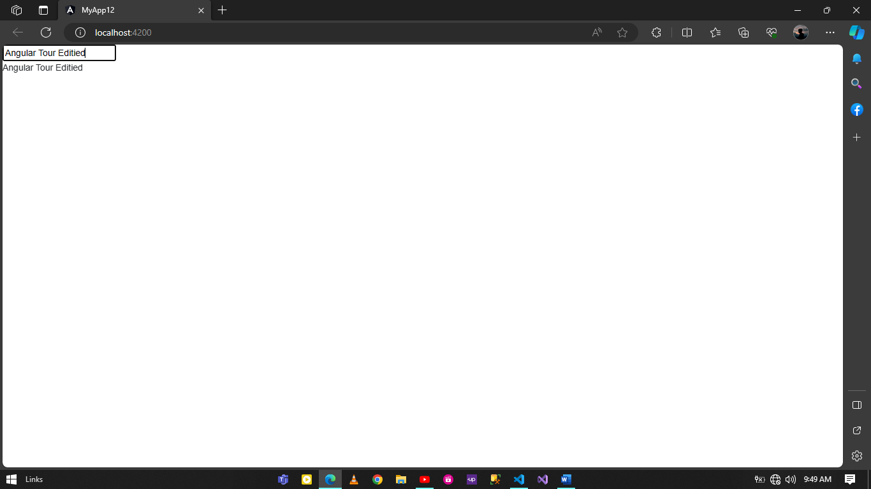

**PIPES**

**Build in pipes**

**app.component.html**

<div>{{ lowerCaseExample | lowercase }}</div>

<div>{{ upperCaseExample | uppercase }}</div>

<div>{{ dateExample  | date }}</div>

<div> {{ jsonExample | json }}</div>

<div> {{ currencyExample | currency:'INR' }}</div>

<div> {{ percentExample | percent }}</div>

**app.component.ts**

import { Component } from '@angular/core';

@Component({

  selector: 'app-root',

  templateUrl: './app.component.html',

  styleUrls: ['./app.component.css']

})

export class AppComponent {

  title = 'Angular Tour';

  lowerCaseExample = "ANGULAR TO LOWERCASE";

  upperCaseExample = "change to uppercase";

  dateExample = Date.now();

  jsonExample = { username : "Rahul", major : "Angular", Experience: "5" };

  currencyExample = 250;

  percentExample = 0.4898;

}

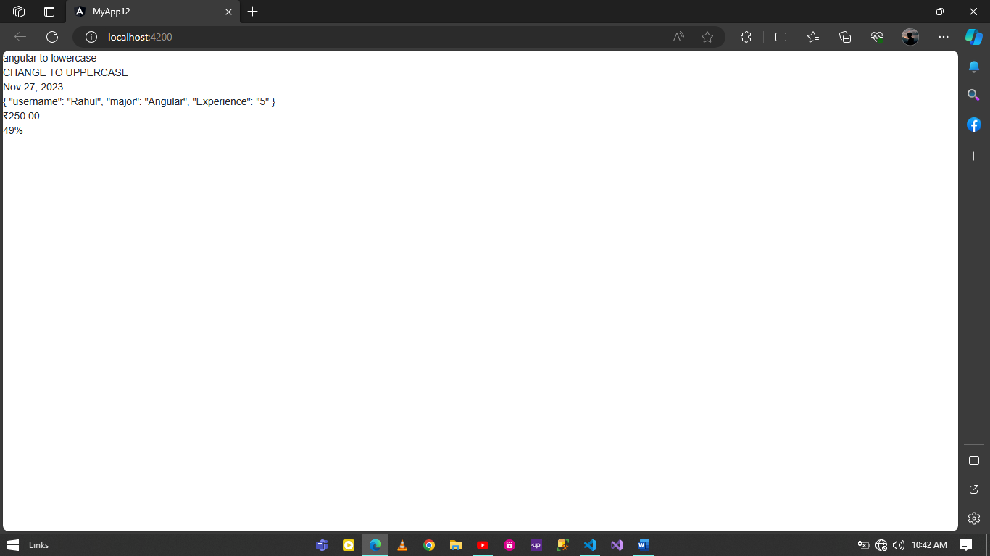

**Build in pipes**

**app.component.html**

<div>{{ lowerCaseExample | lowercase }}</div>

<div>{{ upperCaseExample | uppercase }}</div>

<div>{{ dateExample  | date: 'short'}}</div>

<div>{{ dateExample  | date: 'long'}}</div>

<div>{{ dateExample  | date: 'MMM-dd-yy'}}</div>

<div> {{ jsonExample | json }}</div>

<div> {{ currencyExample | currency:'INR' }}</div>

<div> {{ currencyExample | currency:'CAD' }}</div>

<div> {{ percentExample | percent: '3.2-2' }}</div>

**app.component.ts**

import { Component } from '@angular/core';

@Component({

  selector: 'app-root',

  templateUrl: './app.component.html',

  styleUrls: ['./app.component.css']

})

export class AppComponent {

  title = 'Angular Tour';

  lowerCaseExample = "ANGULAR TO LOWERCASE";

  upperCaseExample = "change to uppercase";

  dateExample = Date.now();

  jsonExample = { username : "Rahul", major : "Angular", Experience: "5" };

  currencyExample = 250;

  percentExample = 0.4898;

}

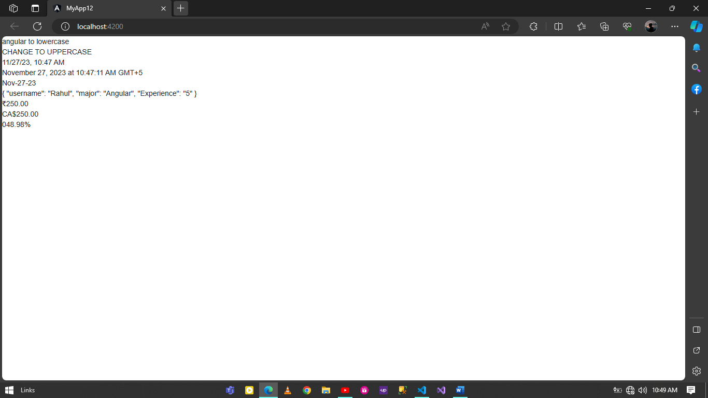

**Chaining Pipes**

**app.component.html**

<div>{{ dateExample  | date |uppercase }}</div>

<div>{{ currencyExample  | currency: 'CAD' | lowercase }}</div>

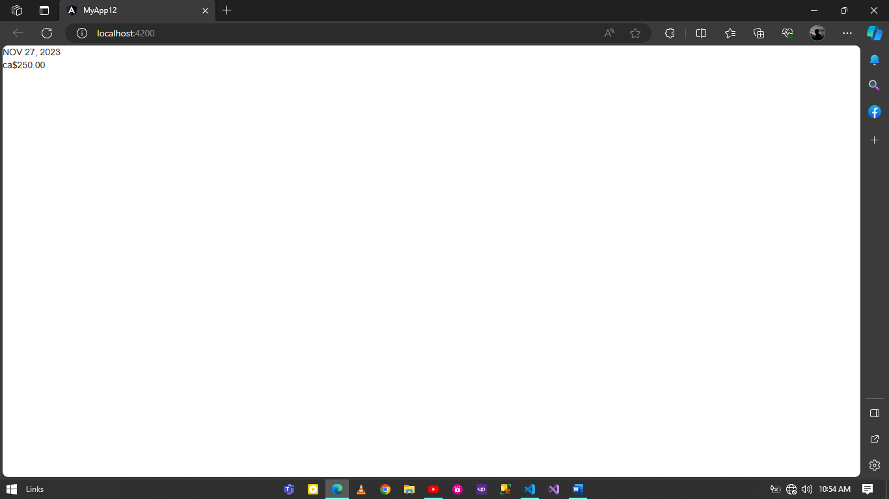

**Angular Routing**

**App-routing.module.ts**

import { NgModule } from '@angular/core';

import { RouterModule, Routes } from '@angular/router';

import { LoansComponent } from './loans/loans.component';

import { LoanTypesComponent } from './loan-types/loan-types.component';

const routes: Routes = [

  {

    path: 'loans',

    component: LoansComponent

  },

  {

    path: 'loan-types',

    component: LoanTypesComponent

  }

];

@NgModule({

  imports: [RouterModule.forRoot(routes)],

  exports: [RouterModule]

})

export class AppRoutingModule { }

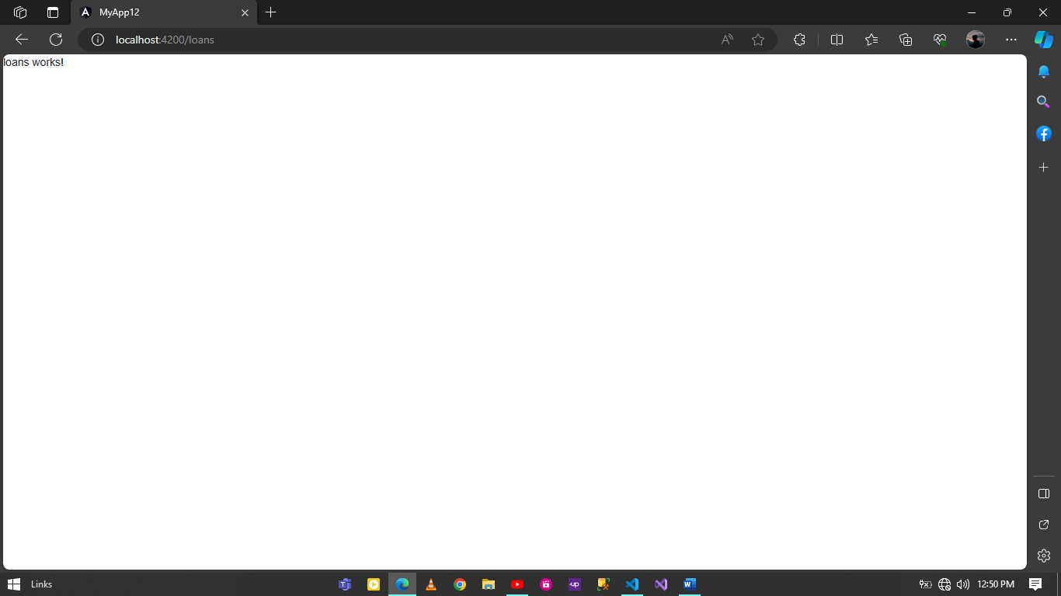

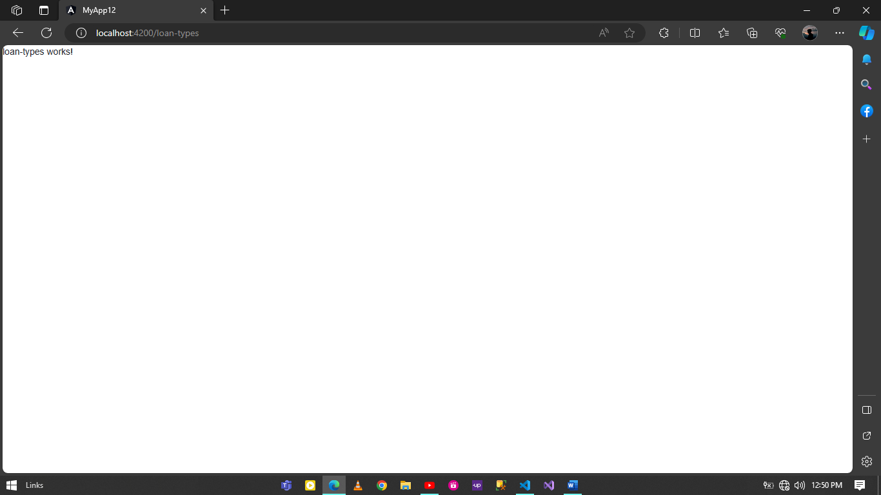

**Router-Outlet**

**app.component.html**

<div>

    This is Angular Application

</div>

<router-outlet></router-outlet>

<router-outlet name="loanType"></router-outlet>

**App-routing.module.ts**

import { NgModule } from '@angular/core';

import { RouterModule, Routes } from '@angular/router';

import { LoansComponent } from './loans/loans.component';

import { LoanTypesComponent } from './loan-types/loan-types.component';

const routes: Routes = [

  {

    path: 'loans',

    component: LoansComponent

  },

  {

    path: 'loan-types',

    component: LoanTypesComponent,

    outlet: 'loanType'

  }

];

@NgModule({

  imports: [RouterModule.forRoot(routes)],

  exports: [RouterModule]

})

export class AppRoutingModule { }

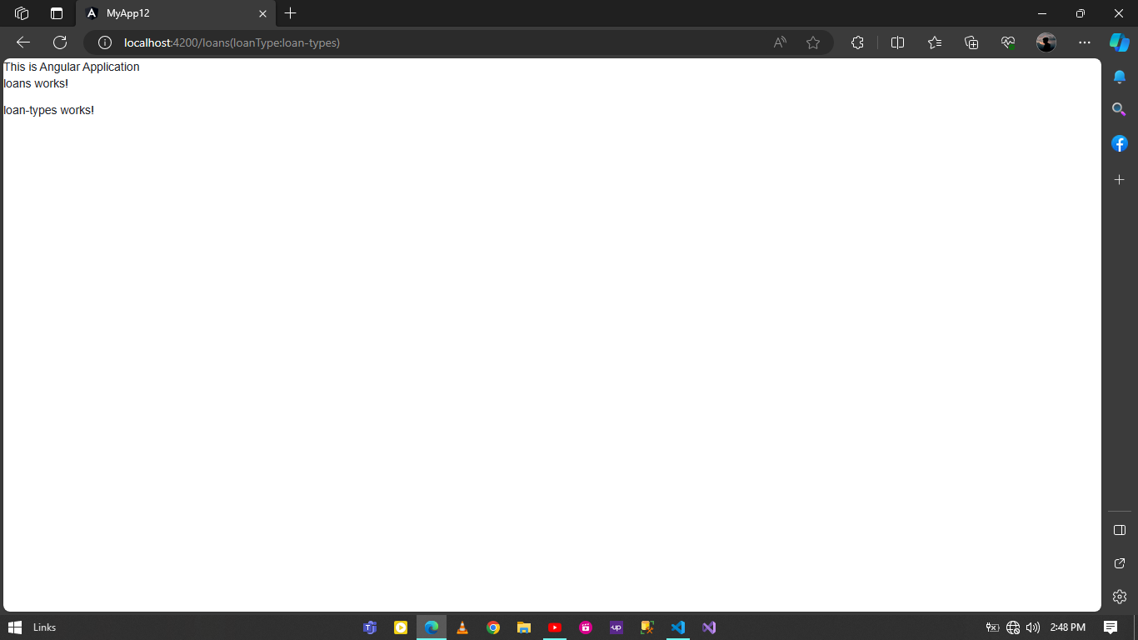

**Parameterized Router in Angular**

**App-routing.module.ts**

import { NgModule } from '@angular/core';

import { RouterModule, Routes } from '@angular/router';

import { LoansComponent } from './loans/loans.component';

import { LoanTypesComponent } from './loan-types/loan-types.component';

import { ProductComponent } from './product/product.component';

const routes: Routes = [

  { path: 'product/:id', component: ProductComponent},

  { path: 'product/:productId/photos/:photoId', component: ProductComponent}

];

@NgModule({

  imports: [RouterModule.forRoot(routes)],

  exports: [RouterModule]

})

export class AppRoutingModule { }

**product.component.ts**

import { Component, OnInit } from '@angular/core';

import { ActivatedRoute } from '@angular/router';

@Component({

  selector: 'app-product',

  templateUrl: './product.component.html',

  styleUrls: ['./product.component.css']

})

export class ProductComponent implements OnInit {

  productId = 0;

  photoId = 0;

  constructor(private activatedRoute: ActivatedRoute) {

    this.activatedRoute.params.subscribe((params) => {

      console.log(params);

      const intervalue = params;

      this.productId = intervalue.productId;

      this.photoId = intervalue.photoId;

    });

   }

  ngOnInit(): void {

  }

}

**product.component.html**

<p>product works!</p>

<p>Product ID : {{ productId }}</p>

<p>Photo ID : {{ photoId }}</p>

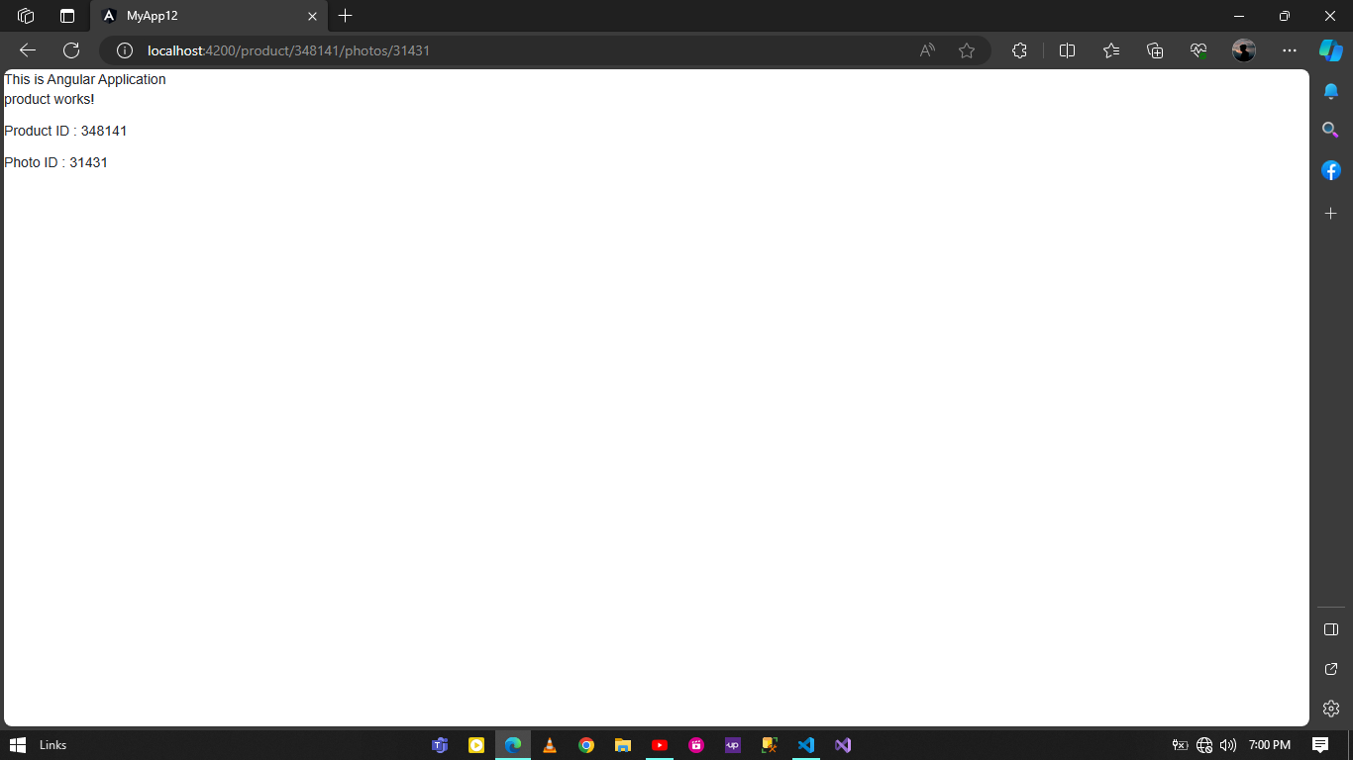

**Router Link**

**clients.component.html**

<p>clients works!</p>

<a [routerLink]="'/user'">User List</a>

<table>

        <th>Client ID</th>

        <th>Firstname</th>

        <th>Lastname</th>

    <tr *ngFor="let client of clientList ">

        <td>{{ client.clientId }}</td>

        <td>{{ client.Firstname }}</td>

        <td>{{ client.Lastname}}</td>

        <td><a [routerLink]="['/user',client.clientId, 'edit']">Edit</a> | <a [routerLink]="['/delete', client.clientId]">Delete</a></td>

    </tr>

</table>

**clients.component.ts**

import { Component, OnInit } from '@angular/core';

@Component({

  selector: 'app-clients',

  templateUrl: './clients.component.html',

  styleUrls: ['./clients.component.css']

})

export class ClientsComponent implements OnInit {

  clientList = [

    { clientId: 10, Firstname: 'John', Lastname: 'Dig'},

    { clientId: 20, Firstname: 'Alen', Lastname: 'Jose'},

    { clientId: 30, Firstname: 'Rahul', Lastname: 'Reju'},

    { clientId: 40, Firstname: 'Amal', Lastname: 'SJ'},

    { clientId: 50, Firstname: 'Santhosh', Lastname: 'George'},

    { clientId: 60, Firstname: 'Veena', Lastname: 'Jose'}

  ];

  constructor() { }

  ngOnInit(): void {

  }

}

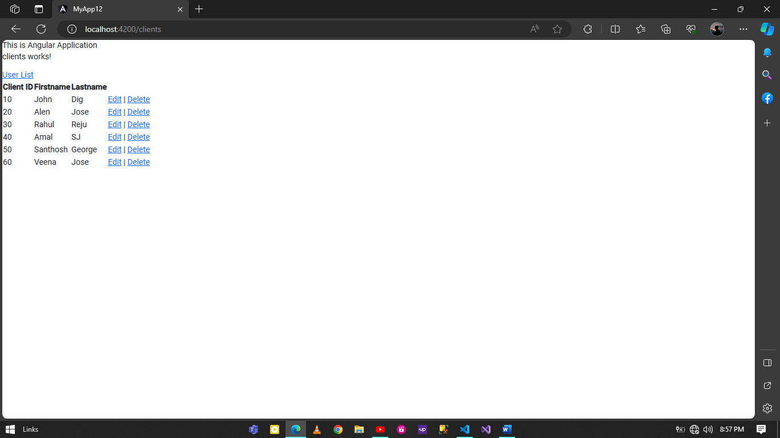

**Query Params**

**search.component.html**

<p>search works!</p>

<h4>Search Criteria</h4>

<p>Color: {{ color }} </p>

<p>Size: {{ size }} </p>

<p>price From: {{ priceFrom }} </p>

<p>price To: {{ priceTo }} </p>

**search.component.ts**

import { Component, OnInit } from '@angular/core';

import { ActivatedRoute } from '@angular/router';

@Component({

  selector: 'app-search',

  templateUrl: './search.component.html',

  styleUrls: ['./search.component.css']

})

export class SearchComponent implements OnInit {

  color = '';

  priceFrom = 0;

  priceTo = 0;

  size = 'M';

  constructor(private activatedRoute: ActivatedRoute) {

    this.activatedRoute.queryParams.subscribe((params) =>{

      this.color = params.color;

      this.priceFrom = params.priceFrom;

      this.priceTo = params.priceTo;

      this.size = params.size;

    })

  }

  ngOnInit(): void {

  }

}

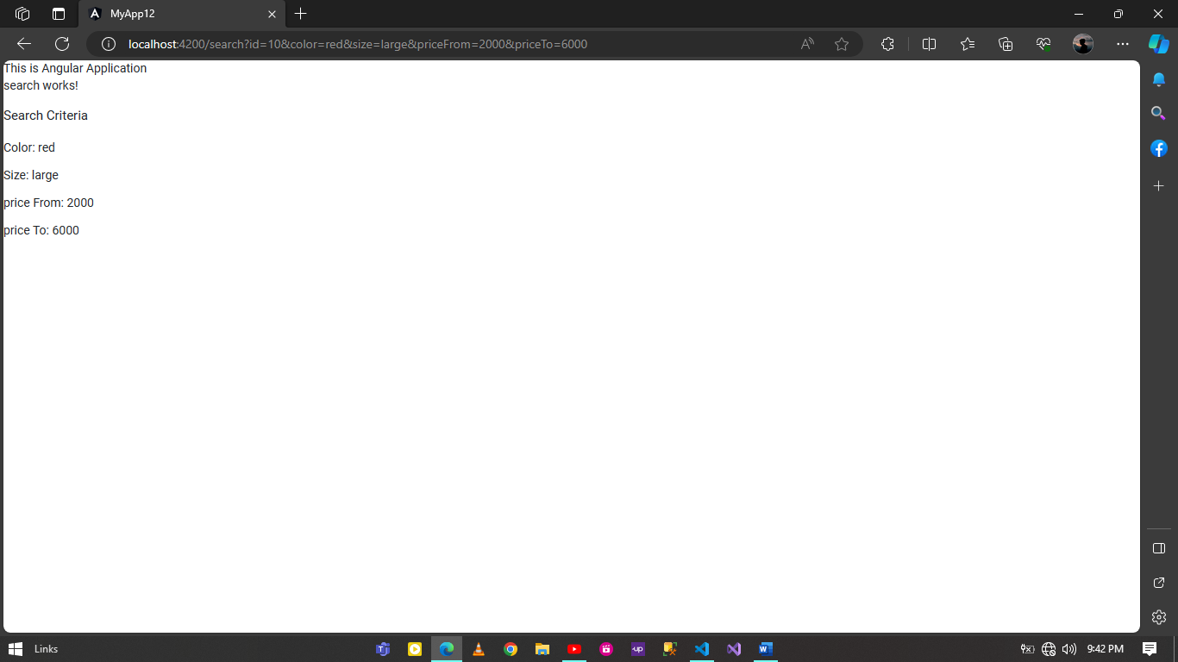

**Lazy Loading**

**Syntax:**

ng g module payments --route payments --module app.module

